**C:\Users\sse\Desktop\logo_01.png**

Software Design Manual

SuPERCAMPUS – 校园综合app

小组成员：吕炎明、刘慧杰、刘宇轩、吴伯泽、吴昊蔚、林业滨

2021

Catalogue

[1 Summary 1](#_Toc91680838)

[2 Introduction 1](#_Toc91680839)

[2.1 Project research background and significance (application scenarios, target population) 2](#_Toc91680842)

[2.1.1 Project research background 2](#_Toc91680843)

[2.1.2 Project research significance 4](#_Toc91680844)

[2.2 Related products and comparison 5](#_Toc91680845)

[2.2.1 Perfect Campus (a practical mobile phone client application for colleges and universities)： 5](#_Toc91680846)

[2.3 Project value and innovation 8](#_Toc91680847)

[3 Development Plan 9](#_Toc91680848)

[3.1 Main function description 9](#_Toc91680850)

[3.1.1 Basic Skills： 9](#_Toc91680851)

[3.1.2 Extensions： 9](#_Toc91680852)

[3.2 Key difficult problem 10](#_Toc91680853)

[3.2.1 OpenCV recognition accuracy is low 10](#_Toc91680854)

[3.2.2 Front and back-end docking is complicated 10](#_Toc91680855)

[3.2.3 Realization of component animation effects 10](#_Toc91680856)

[3.3 Schedule 11](#_Toc91680857)

[3.3.1 Development Model 11](#_Toc91680858)

[3.1.1 Project division of labor arrangement 12](#_Toc91680859)

[3.1.2 Project Contribution Table 12](#_Toc91680860)

[4 Feasibility Analysis 13](#_Toc91680861)

[4.1 Market feasibility analysis 13](#_Toc91680863)

[4.2 Technical feasibility analysis 14](#_Toc91680864)

[5 Demand Analysis 14](#_Toc91680865)

[5.1 User needs 14](#_Toc91680867)

[5.2 Functional needs 16](#_Toc91680868)

[5.2.1 Function module structure diagram 16](#_Toc91680869)

[5.2.2 Core function module description 17](#_Toc91680870)

[5.3 Use case 19](#_Toc91680871)

[5.4 Non-functional demand 19](#_Toc91680872)

[6 Software Design 21](#_Toc91680873)

[6.1 Software Flowchart 21](#_Toc91680875)

[6.2 Software Structure Class Diagram 22](#_Toc91680876)

[6.2.1 Client class diagram 22](#_Toc91680879)

[6.3 Software System Architecture 23](#_Toc91680880)

[6.4 Database ER Diagram 24](#_Toc91680881)

[6.5 Back-end Tech 24](#_Toc91680882)

[6.5.1 FastDFS 24](#_Toc91680886)

[6.5.2 Nginx 25](#_Toc91680887)

[7 Software Implementation 26](#_Toc91680888)

[7.1 Software interface display 26](#_Toc91680889)

# Summary

The development of mobile Internet and smart phones has promoted the widespread use of mobile apps, and the amount of information on campus is very large, and campus apps can facilitate students’ study and life, so this project builds campus information based on the Android platform based on campus life The aggregation platform provides information services to campus users and displays campus culture to users outside the campus. It mainly realizes functions such as campus news, timetable query, lost and found, second-hand trading, club activities, website navigation, etc.

# Introduction

In recent years, campus apps have been rapidly developed among Chinese colleges and universities, and most colleges and universities now have their own campus apps. Factors that promote the rapid development of campus APPs, on the one hand, due to the all-round popularization of the Internet and mobile devices among college students, almost manpower at least one smart mobile terminal; on the other hand, due to the rapid development of open source software and the gradual visualization of operations, it is for non-professionals People can also develop an APP in a short time; at the same time, the construction of campus informatization and the support of many national policies make the development of campus APP present a prosperous situation.

At present, campus apps are classified according to their target users, and are mainly divided into two categories: The first category focuses on one or several colleges and universities, and is dedicated to serving the teachers and students of the school, such as "AtTsinghua" and "iFudan", which focus on Serving the colleges and universities; the second category is for students from major colleges and universities across the country, such as "super curriculum" and "black and white campus".

However, the quality of campus apps is uneven, and some of them have been widely used in a wide range of applications, but at the same time, due to the lack of features and other reasons, many campus apps are ultimately unpopular.



## Project research background and significance (application scenarios, target population)

### Project research background

The rapid development of Internet technology and mobile smart terminals has prompted more and more college students to be more willing to connect to the Internet through mobile smart terminal platforms, and campus apps have attracted more and more attention from teachers and students. The management departments of universities, students and professional R&D teams of enterprises have followed the mobile trend closely, chose the latest development technology, and took advantage of their own resources to design applications suitable for mainstream mobile platforms, with diverse forms and rich content. The needs of users in different universities are not the same, and the level of software development technology of each enterprise is also different, and the mobile services provided are also different. College students’ acceptance and reliance on various information platforms are generally very strong, but the life service application software on the market is a mixed bag. According to the needs of college students, the application software that provides information to facilitate the study and life of college students is also based on the interests of college students. Very few. Mobile informatization construction has become an important development direction of college informatization construction. Although new media forms such as WeChat and Weibo are commonly used by college students, they are subject to certain restrictions in the transmission of information and the art of interface. The campus APP can better meet the needs of users in these aspects.

As the generation closest to the information age and mobile phone networks, contemporary students are more comfortable with this new technology. APP is a software with various functions relying on the mobile phone as the carrier, and the mobile phone is light and convenient and is an indispensable device for modern people. Therefore, this makes APP has the characteristics of convenience, efficiency, and fun, and attracts contemporary youth, making it a powerful main force.

APP is even more attractive to the new generation of teenagers. There are many kinds of APPs on the market, and it satisfies the curiosity and uniqueness of this generation. All kinds of software enable part-time internships to find jobs, learn to answer questions, financial credit, life purchases, social entertainment and other activities can be realized at any time and place through mobile phones. Although there are many such softwares, they have no sense of belonging and control on the campus as a whole. The use of software functions is also scattered and complicated to use, which cannot bring students a long-term benefit line. Nowadays, there are not many diversified and unified APPs set up specifically for campuses on the market. Some campus APPs are mostly small in scale and more restrictive, and cannot realize the use and promotion of a nationwide campus APP. Therefore, a comprehensive campus APP that specifically meets the needs of students and can combine study and life is even more urgent.

### Project research significance

There are many application services of college apps. Many colleges and universities classify them according to their service functions. The service functions provided by each school are not very consistent. However, SuperCampus integrates the resources of colleges and universities to make a truly comprehensive campus service app. Campus pass in the sense. The current world is a rapidly developing information age. With the development of network information technology, mobile terminal software and hardware have also developed rapidly in recent years. The third-party application App for smart phones has become one of the important entrances to the mobile Internet. All kinds of APP software developed using mobile phones as a medium, from learning, making friends, entertainment to shopping, have changed people's previous lifestyles, which has made people more and more connected, their lives have become more and more convenient, and the economy has also been driven.

In order to create a truly comprehensive campus service app, our team developed the SuperCampus app after integrating functions and user needs to meet the needs of college students in daily life, learning, and entertainment.

## Related products and comparison

### Perfect Campus (a practical mobile phone client application for colleges and universities)：

A comprehensive service platform with the theme of "easy life, happy growth" for college students. It includes the following system functions and services：

1. 充值缴费

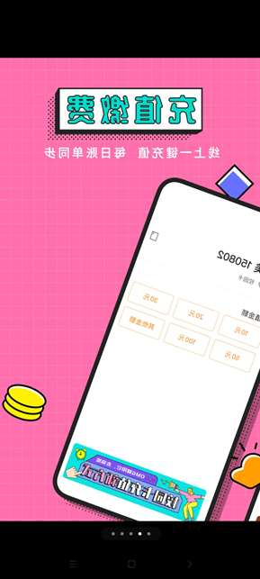

2. 付款支付

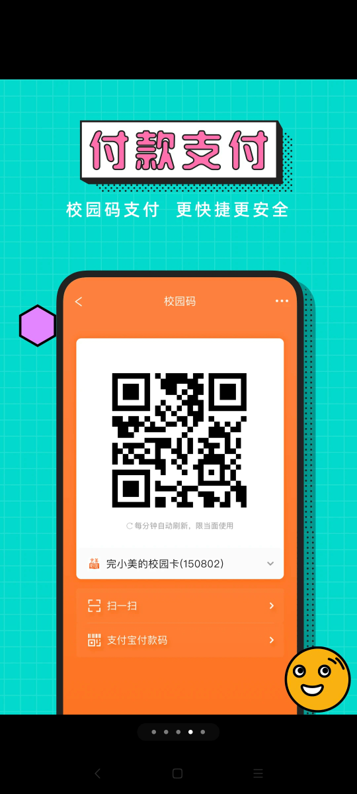

3. 课程表

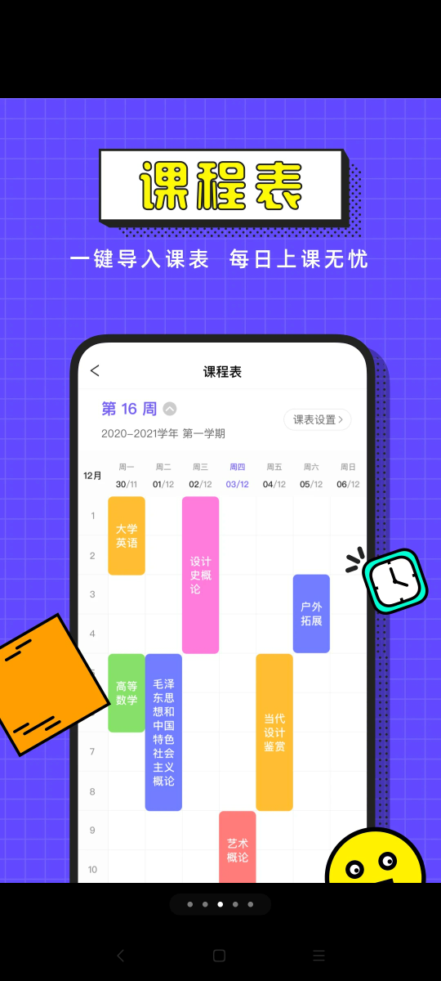

4. 求职招聘

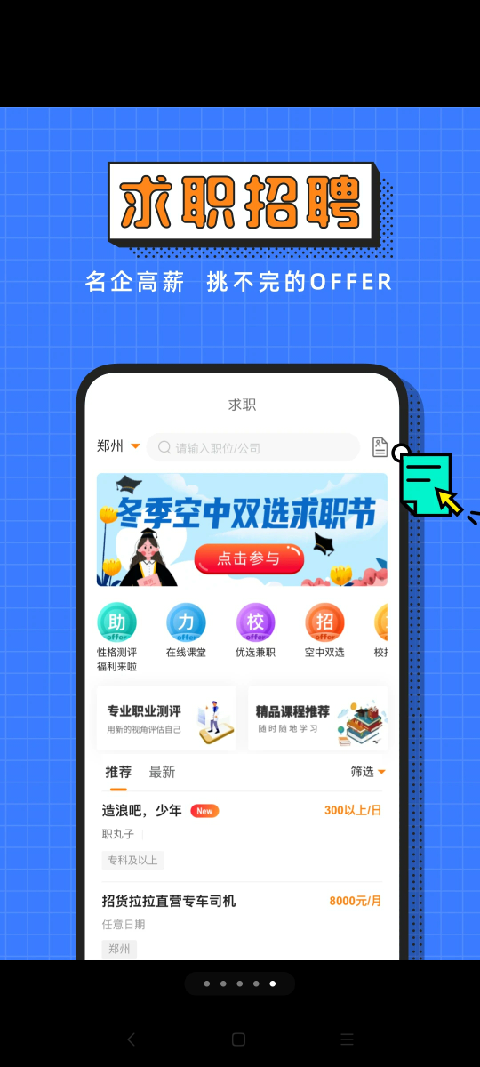

Our shortcomings：

Due to the contradiction between the tight time and the complexity of the system program, our group is currently unable to access the school’s data interface.

Our advantage：

1. Our App has functions that have perfect campuses, for example: Lost & Found, Message Wall, Friends.
2. Our App can access to campus database so we can provide the campus student with a convenient, easy and efficient access to school information.
3. Our app users are only students of our school, so different from those general campus apps, we can combine the characteristics of our school and integrate the elements of our school in the app to provide better services for our students

## Project value and innovation

Compared with the official website, mobile applications have incomparable advantages in terms of convenience, interactivity, and user stickiness. For example, in the past, users had to use a browser to log in to campus websites, enter a domain name or search for a website before entering, and some websites were difficult to search through search engines and required IP addresses to access, such as some school educational administration systems. Under the fast-paced living conditions of today's information age, such an operation process is undoubtedly too cumbersome. And use this campus APP to aggregate frequently used websites on campus to provide information support for campus users. Users do not need to use a browser to enter the corresponding website, which is convenient for teachers and students to obtain information services.

# Development Plan



## Main function description

### Basic Skills：

* 1. User login, registration
  2. App Features Homepage
  3. Class Schedule

### Extensions：

1. Notification
2. Lost and Found
3. Message Wall
4. Friends
5. User Own Page

## Key difficult problem

### OpenCV recognition accuracy is low

OpenCV is a cross-platform computer vision and machine learning software library that can be run on Linux, Windows, Android, and Mac OS operating systems. It is lightweight and efficient, consists of a series of C functions and a small amount of C ++ classes, and provides a multi-general algorithm for image processing and computer visual aspects.

But OpenCV is not very satisfactory in the accuracy of object identification.

### Front and back-end docking is complicated

The backend of this project uses the gin framework. Gin is a web framework written in Go language. It has fast run speed, grouped routers, good crash capture and error handling, and very good support for middleware and json.

However, when we did the docking, problems such as json parsing errors caused by the inconsistent json format, inconsistent front-end and back-end data, etc., caused the progress of the project to be seriously slowed down.

### Realization of component animation effects

We have designed a lot of animation effects for the app for the app. In fact, these animation effects in Android Studio are very difficult.

## Schedule

### Development Model

This project adopts an agile development model, multiple iterations, work in a short iteration cycle, each iteration delivers some results, and can submit and show part of the function every week. Agile development is a human-centric, iterative, and gradual development method. In agile development, the construction of a software project is divided into multiple sub-projects, and the results of each sub-project have been tested and have the characteristics of integration and operation. In other words, it is to divide a large project into multiple small projects that are interconnected, but can also be run independently, and completed separately. During this process, the software is always in a usable state.

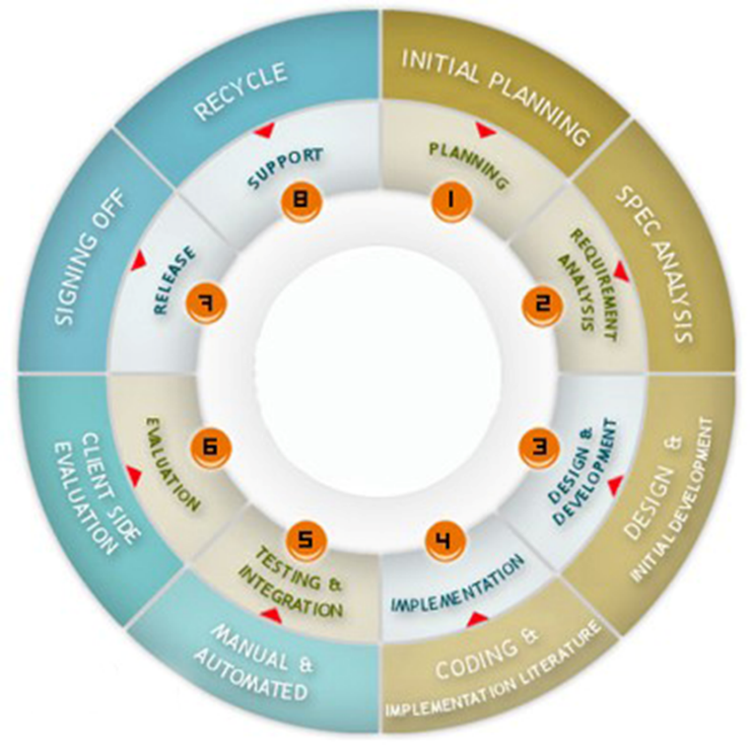

### Project division of labor arrangement

The division of labor for this project is arranged as follows：

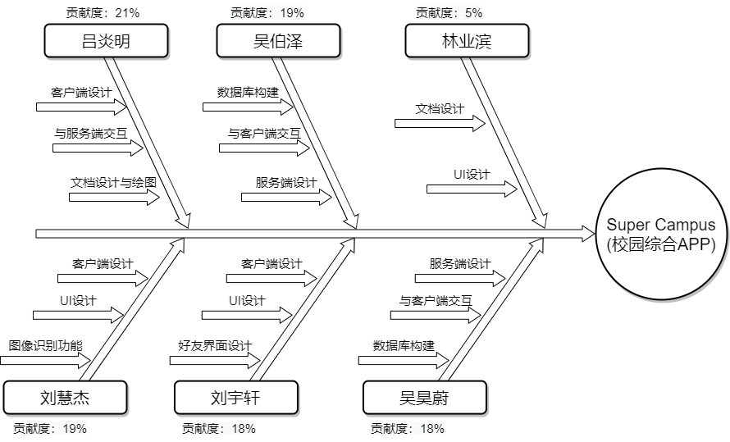

### Project Contribution Table

|  |  |  |  |
| --- | --- | --- | --- |
| Name | Student Number | Contribution | Rate |
| 吕炎明 | 19301014 | 客户端设计、与服务端交互、文档设计与绘图 | 21% |
| 刘慧杰 | 19301012 | 客户端设计、UI设计、图像识别 | 19% |
| 刘宇轩 | 19301013 | 客户端设计、UI设计 | 18% |
| 吴伯泽 | 19301017 | 数据库构建、服务端设计、与客户端交互 | 19% |
| 吴昊蔚 | 19301018 | 数据库构建、服务端设计、与客户端交互 | 18% |
| 林业滨 | 19301011 | 文档设计、UI设计 | 5% |

# Feasibility Analysis



## Market feasibility analysis

College students have a very strong ability to quickly accept new things. As the generation closest to the information age and mobile phone networks, contemporary students are more comfortable with this new technology. APP is a software with various functions relying on the mobile phone as the carrier, and the mobile phone is light and convenient and is an indispensable device for modern people. Therefore, this makes APP has the characteristics of convenience, efficiency, and fun, and attracts contemporary young people, making it a powerful main force.

APP is even more attractive to the new generation of teenagers. There are many kinds of APPs on the market, and it satisfies the curiosity and uniqueness of this generation. All kinds of software enable part-time internships to find jobs, learn to answer questions, life purchases, social entertainment and other activities can be realized at any time and place through mobile phones. Although there are many such softwares, they do not have a sense of belonging and control on the campus as a whole. The use of software functions is also scattered and complicated to use, which cannot bring students a long-term benefit line. Nowadays, there are not many diversified and unified APPs set up specifically for campuses on the market. Most of the campus APPs are small in scale and more restrictive, which cannot realize the use and promotion of a nationwide campus APP. Therefore, a comprehensive campus APP that specifically meets the needs of students and can combine learning, social life and life is even more urgent.

## Technical feasibility analysis

Currently, colleges and universities have a large number of information websites. Users need to use a browser to access, and some of them do not have an Android browser. For example, our school’s course platform. The operation process is undoubtedly too cumbersome and wastes a lot of time. If this app is successfully developed, it will help teachers and students obtain campus information better and faster, and enrich campus life. Considering long-term benefits, if the project can be successfully developed, the benefits it will bring will be much higher than the system investment

# Demand Analysis



## User needs

Campus service needs：

At present, most of the universities services are fixed machine service, and the Supercampus access to the school interface to the classmates more convenient service terminals. The user provoked the time to wait in the machine, and also provide more diversified life services to you, for example: dating platform provides you with better college friendship services, the information wall makes everyone know more about the latest Information

Comprehensive demand：

Supercampus Comprehensive School Foreign Ministry Crafts Create a more complete campus comprehensive service platform while subverting the old campus ecology, putting the campus service and business combination of campus and unruly without uniform organizational management, safer more convenient services. Moreover, the market's service service application software is mixed, for college students 'needs, with the interests of college students, the basic starting point provides information, which is convenient for college students' learning life, and less. Supercampus not only provides university students with mobile campus services while meeting students' live entertainment needs. The culture of colleges and universities are both a campus culture and a part of social culture, which has the characteristics of mass and unique. The new generation of college students are keen on a variety of fashion, trendy "cultural entertainment" ways as this as a manner that highlights its own personality, which has indicated the huge potential of market culture consumption in colleges and universities. In the universal culture, the universal culture will also trigger a boom of new round of cultural consumption, and the rapid development of the network has enabled campus culture to accelerate communication and expansion. This trend will break the past campus culture only as a social culture. The phenomenon of existence, and the campus culture of various colleges and universities will be unified, interactive, active, making cultural consumption a consumer hotspot that cannot be ignored.

## Functional needs

### 5.2.1 Function module structure diagram

This project is designed to design a comprehensive campus app. Target is to get user more convenient to get campus information.

In order to successfully achieve demand, the system requires the following functional modules: database module, server module, and client module. Among them, in order to implement the interaction between servers and clients, it is also necessary to focus on implementing the client's service request module, data receiving module, and service request parsing module, requiring result resolution module. As shown below：

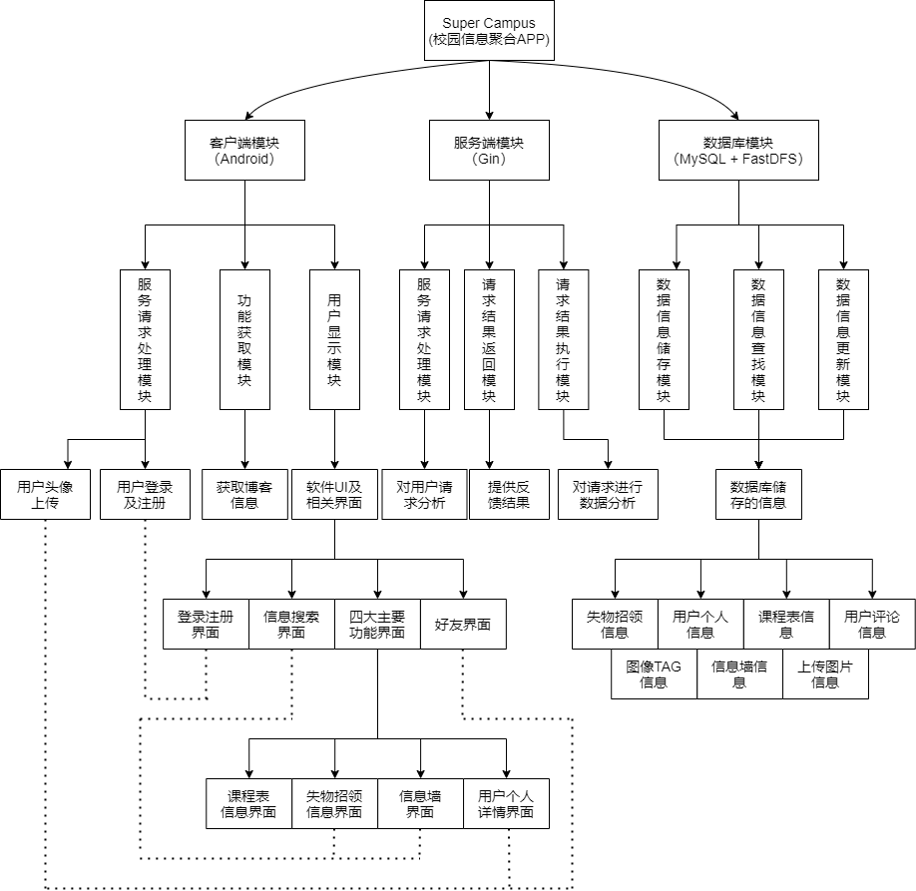

### 5.2.2 Core function module description

#### 5.2.2.1 Database module

This module is mainly used to store various information. The users library is used to store the user's nickname, user name, password, mobile phone number and avatar and other related information. The schedule library is used to store the curriculum related information, and the blogs library is related to lost and found, Information related to the information wall.

#### 5.2.2.2 Server module

This is a very critical core module used to interact with the client used by the user and the database that stores the data.

#### 5.2.2.3 Client module

The user module is the part directly used by the user, which provides the user with the function of interacting with the server, and the user obtains various campus information after logging in it.

## Use case

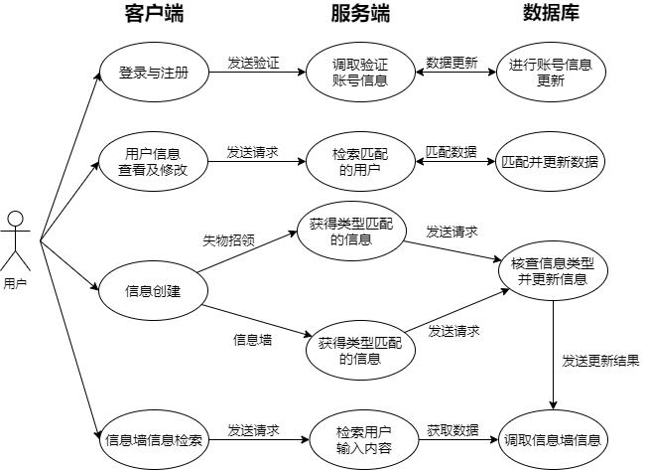

## Non-functional demand

In addition to completing all the features required for the navigation system in the mall, we also consider some non-functional demand from the perspective of humanization.：

（1） Information is instantly. The information in the school is updated quickly, and should ensure that users can get the latest information.

（2） The fluency of the system. The system must guarantee that the user is easy to understand, smooth operation, and the user has a good user experience.

（3） privacy protection. During the process of customer use, the various information about users are collected, avoid leaking the user's privacy data, so that users can safely use it safely.

（4） Scalable and maintainable. Project code should indicate annotations, convenient follow-up to adjust and iterate.

# Software Design



## Software Flowchart

The software flow chart expected by this project is shown below, the following figure shows the flow execution time when the user starts the client：

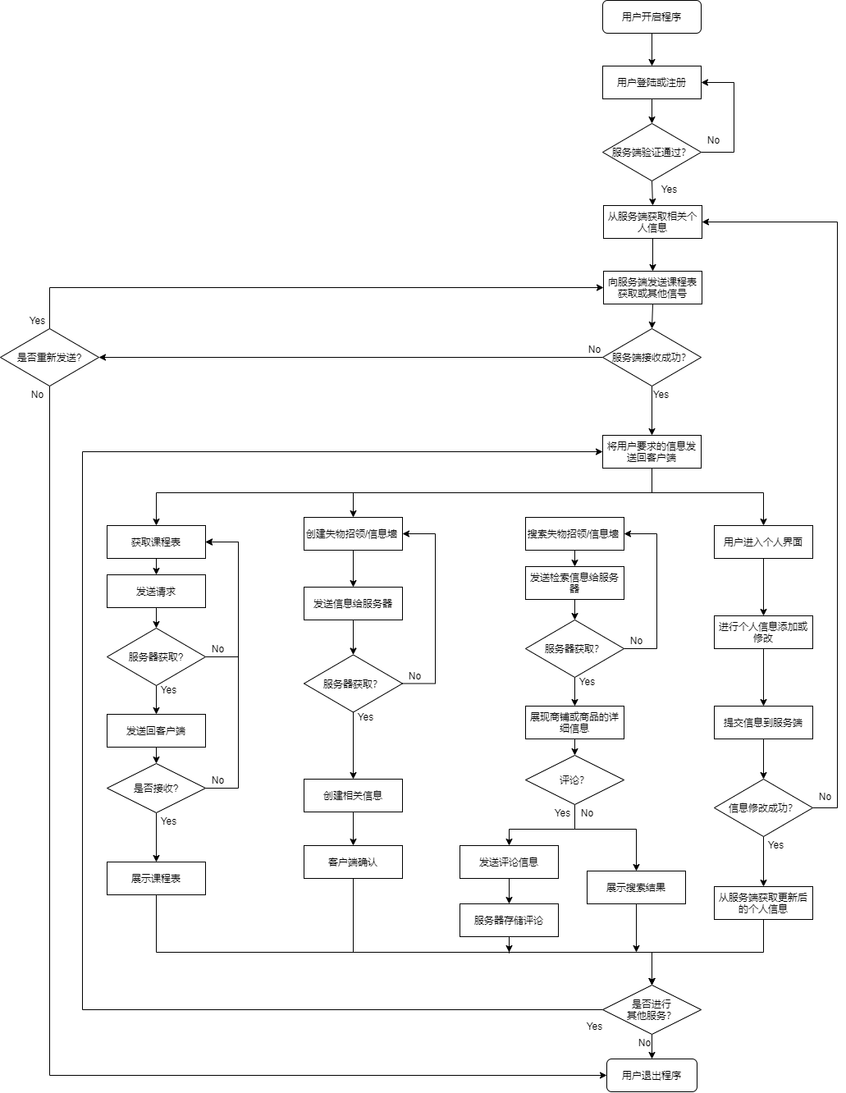

## Software Structure Class Diagram

Under the current development progress, the software UML map of this project is shown below, take into account the image size problem, this software class diagram is detailed in attachments：



### Client class diagram

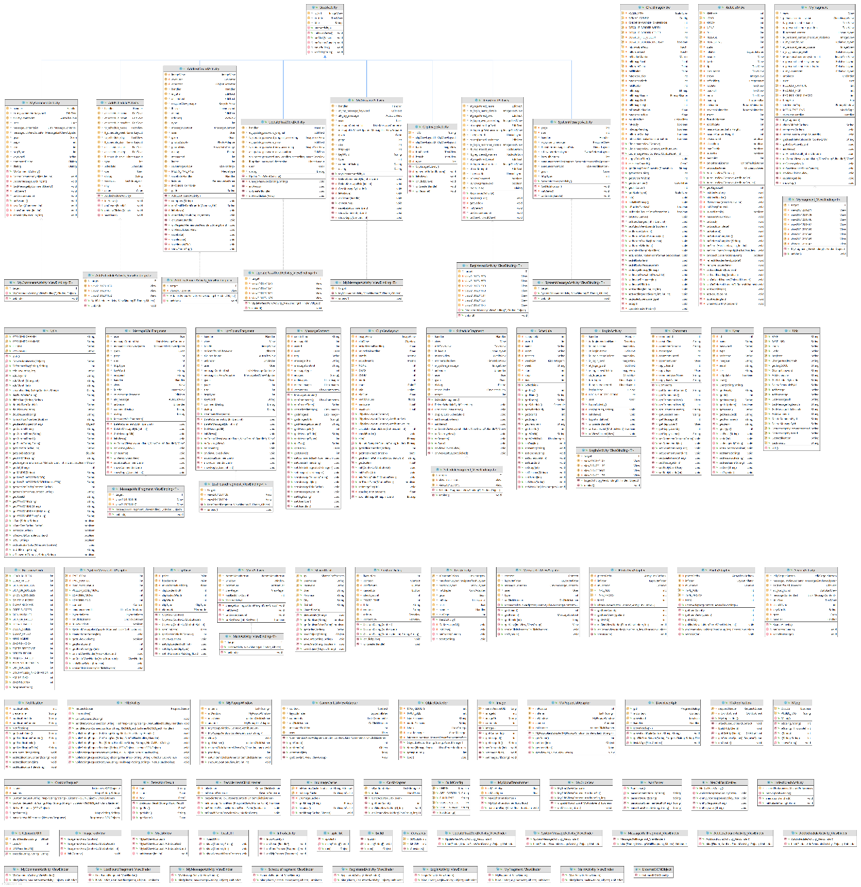

## Software System Architecture

This project uses a system architecture design separated by the client and the server, and sends a request by the client, request processing and database read writing, update, etc. The software system architecture diagram of this project is shown below：

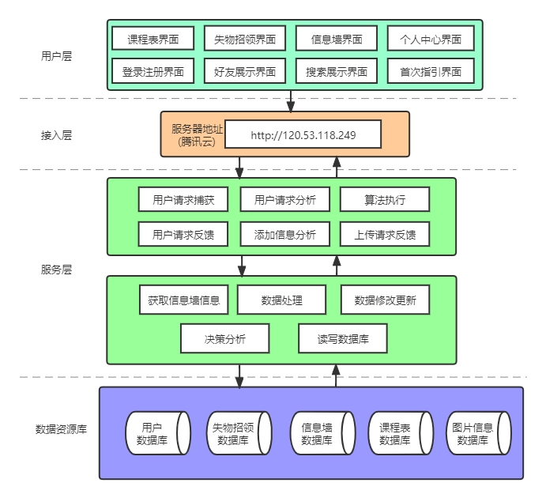

## Database ER Diagram

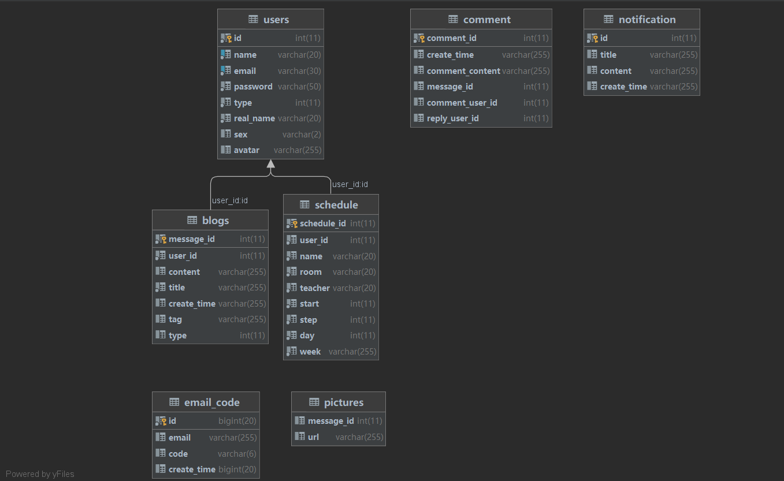

## Back-end Tech



### FastDFS

FastDFS is an open-source high performance distributed file system. Its major functions include: file storing, file syncing and file accessing (file uploading and file downloading), and it can resolve the high capacity and load balancing problem. FastDFS should meet the requirement of the website whose service based on files such as photo sharing site and video sharing site.

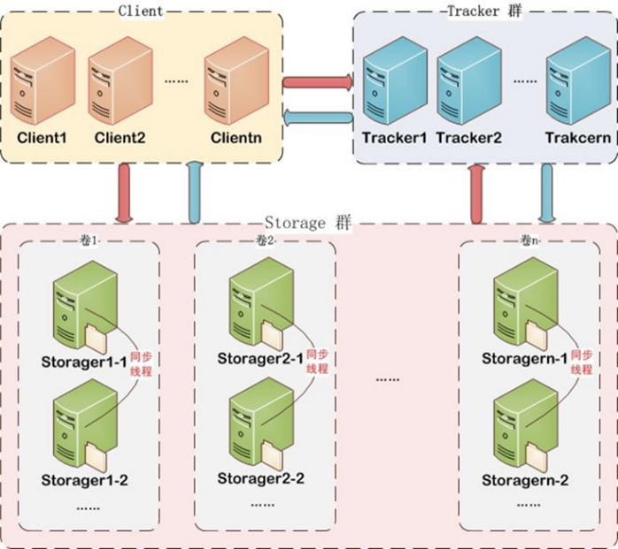

### Nginx

Nginx is a lightweight web server / reverse proxy server and e-mail (IMAP / POP3) proxy server, which is distributed under BSD like protocol. It is characterized by less memory and strong concurrency. In fact, nginx's concurrency performance is better in the same type of web server.

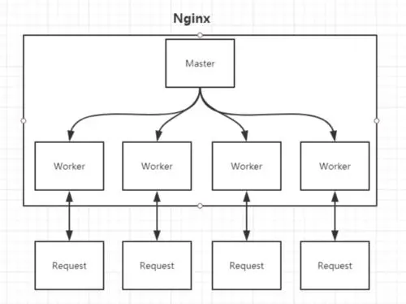

# Software Implementation

## Software interface display

The software running interface of this project is shown in the figure below：

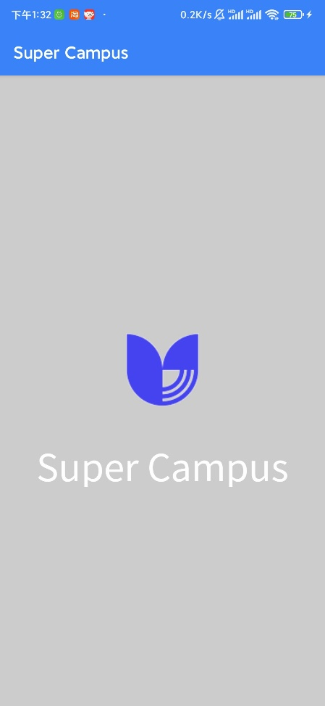 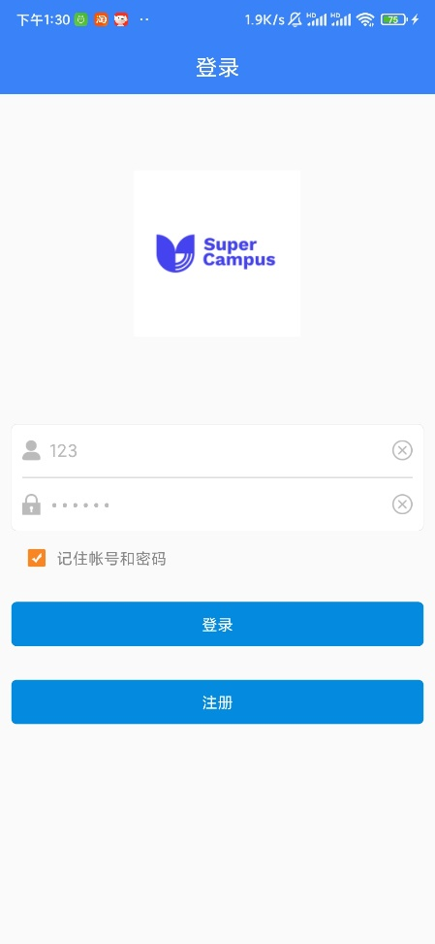

Open screen interface Login Page

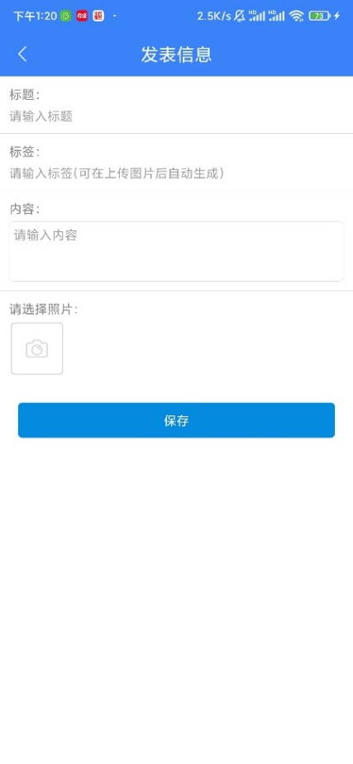 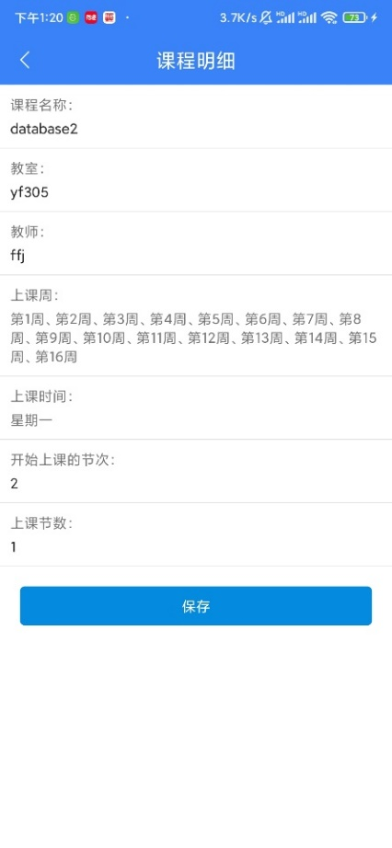

Information release interface Course schedule details interface

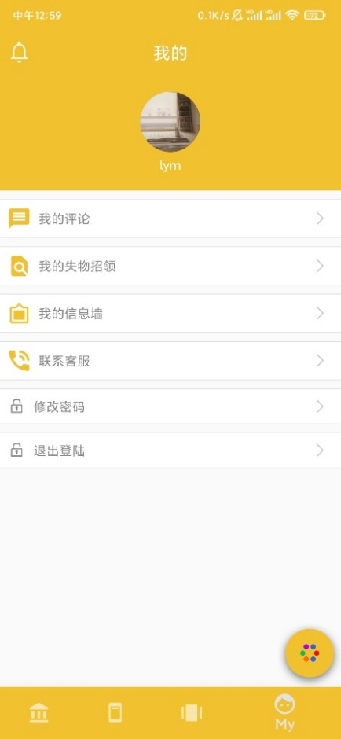 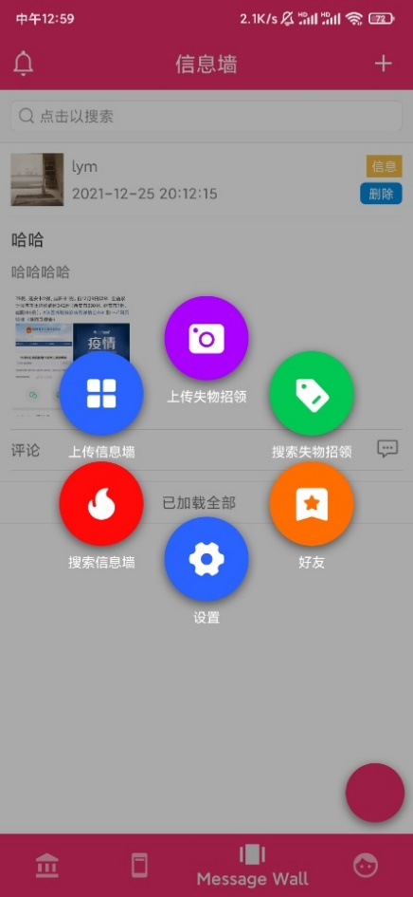

User personal interface Boom button interface

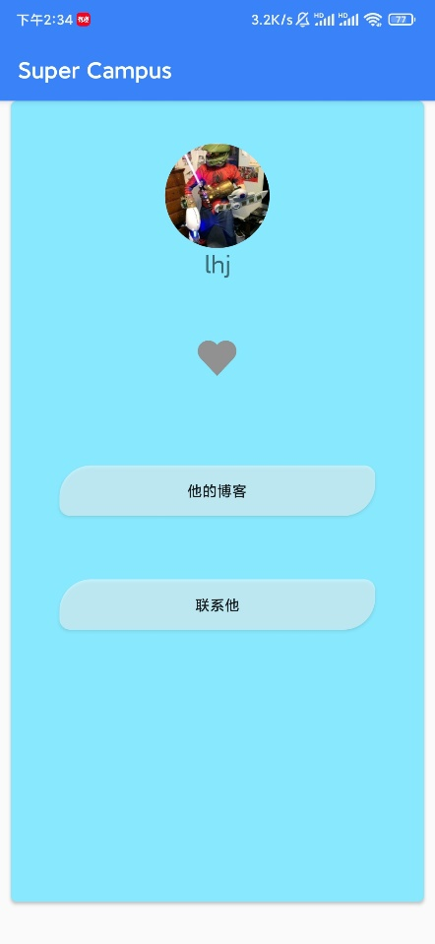 

Friends Page Picture detail page

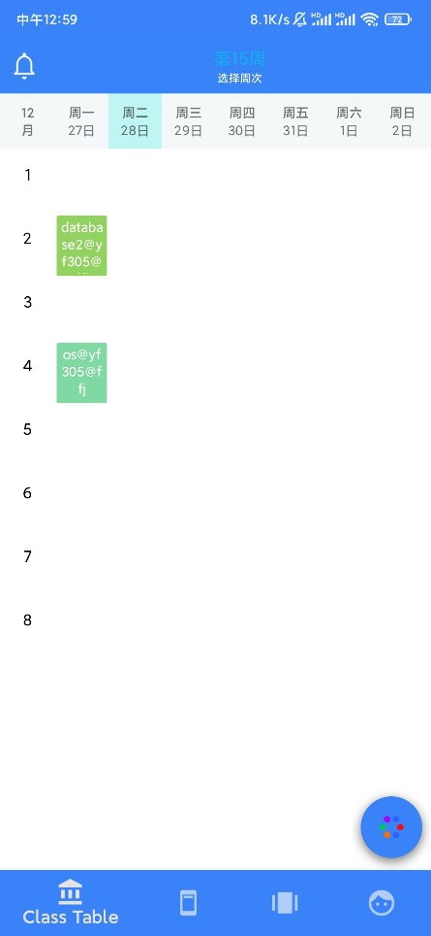 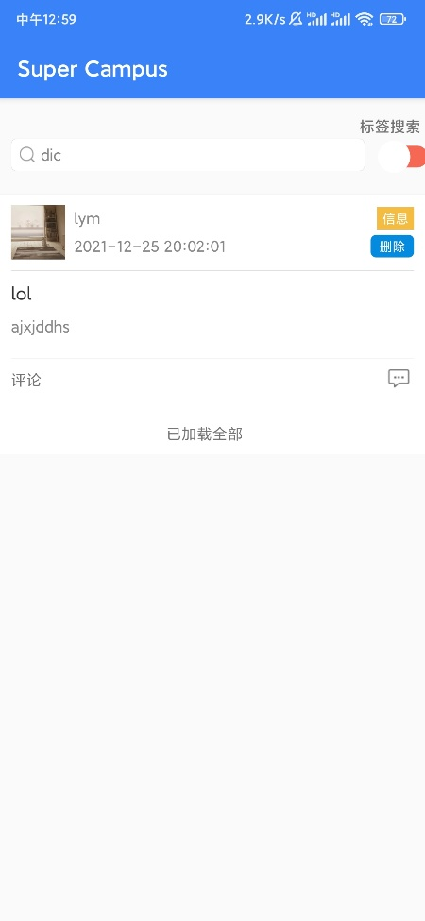

Curriculum Interface Search Page